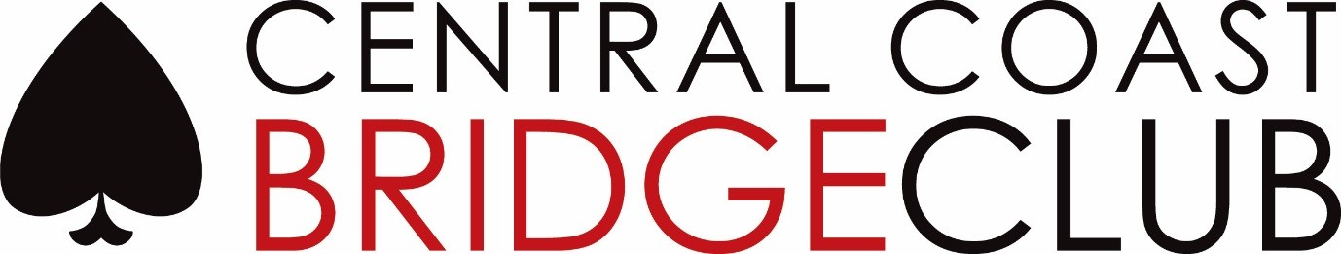
415 THE ENTRANCE RD LONG JETTY 2261
ABN 17835429263

Correspondence to P.O. BOX 6083 LONG JETTY 2261
Phone (02) 4339 3824 | Email ccbridgeclub@gmail.com
| Website: www.centralcoast.bridge-club.org

2024 AGM APOLOGY FORM

I am unable to attend the 2024 AGM, and would like to tender my apologies.

_______________________ ________________________

Printed name Signature

_

